**A PROJECT**

**ON**

**Online Finance Accounting**

**System**

**SUBMITTED BY:**

**Harshil jani**

(Enrollment No.: 201806100110081)

Semester 3-A

**Parth Desai**

(Enrollment No.: 201806100110091)

Semester 3-A

**System Analysis and Design**

**Babu Madhav Institute of information Technology**

**Uka Tarsadia University, Bardoli, GJ**

1. **Introduction**
   1. **Purpose**

To accumulate and report on financial information about the performance, financial position and cash flow of a business. This information is then used to reach the decision about how to manage the business or invest in it or lend money to.

* 1. **Scope**

This system is a web based (online) Accounting & financial management system. Provided via the concept of Software As a Service (SaaS).This system is used by personal, low-end market and mid-end market.

1. **System Analysis**
   1. **Identification of Need**

In Existing Systems, accounts are managed manually while in our system it has been done online and it is automatically.

Using this system, company’s accountant just has to upload their company data online in our website and their reports will be generated.

This system will help the CEO of the company to take the financial decision of his/her company.

* 1. **Functionalities**
* **Functional Requirements**
  + - * + **General Ledger Module**: Financial data is required for creating the general ledger by the user.
        + **Chart of Accounts Module**: The chart of accounts uses a series of codes to identify assets, income, expenses, and equity being tracked by the accounting system.
        + **Trial Balance Module**: The trial balance is used to create all other financial statements, including the balance sheet, income statement and cash flow statement.
        + **Balance Sheet Module**: The balance sheet is used to create reports on cash flow, budgets and conduct other financial analysis of the business’s financial condition.
        + **Accounts Receivable Module**: The accounts receivable module handles the invoicing of customers and processing of customer payments.
        + **Accounts Payable Module**: The Accounts Payable module tracks money due to vendors, discounts, and payment terms for all invoices.
        + **Sales Module:** The Sales Module provides in-depth insight into the main business processes of sales and distribution**.**
        + **Reports:**
* Profit/Loss reports
* Sales Report
* Sales by customer
* Sales by Product
* Expense Report
* Expense Detail
* Supplier Detail
  + Accountant
* General Ledger
* Trial Balance
* **Non-Functional Requirements**
* User Friendly
* Security
* Performance
* Maintainability
* Availability
* **Distinct Functionality:**
* Live chats with users.
* Sign-up with Google Account
* DSS Report Generation
  1. **User Characteristics**
     + **Admin:**
* Can keep track for the System.s
* Can able to view registered company details**.**
  + - **Company Accountant:**
* Will able to manage entries of sales module, expense module and accounting module.
  + - **CEO of the Company:**
* Can manage employee details.
* View statistically reports of Company as below and make decision accordingly**.**
  1. **Constraints and Assumption**
* Cost of Training
* Disruption
* System Failure
* Inability to check unanticipated error.

1. **DFD(data flow diagram)**

**3.1. (context level)**

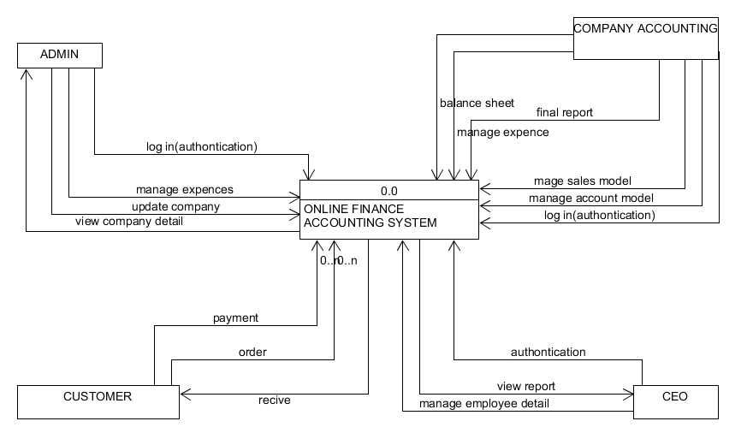

**3.2. (zero level diagram)**

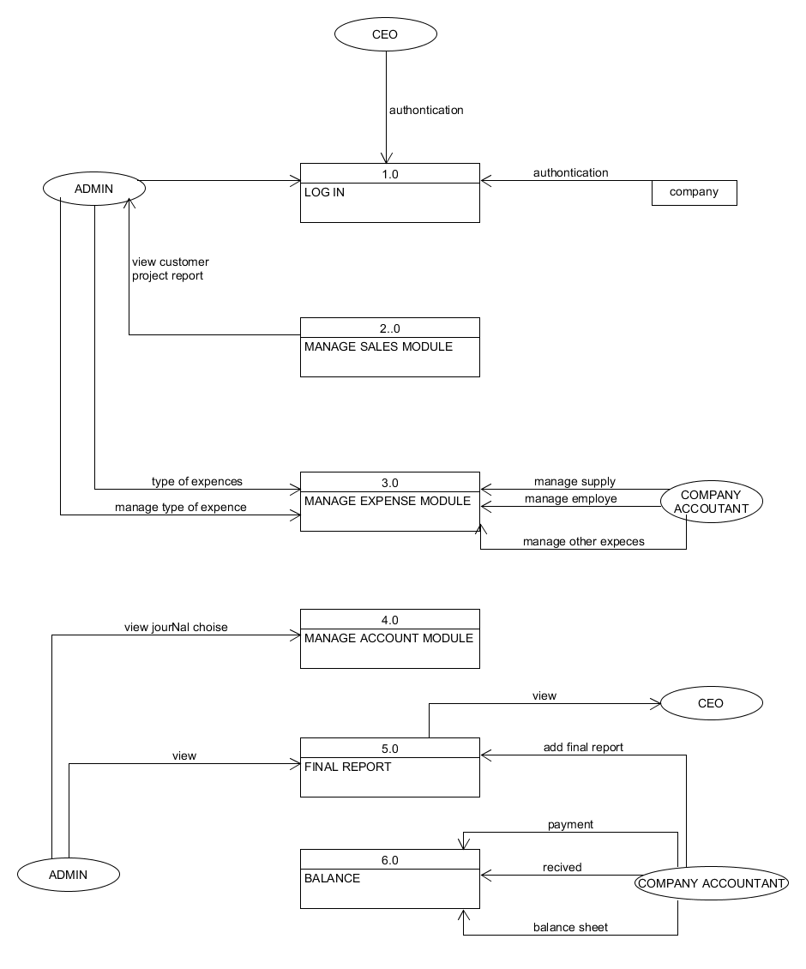

**3.3. (first level diagram)**

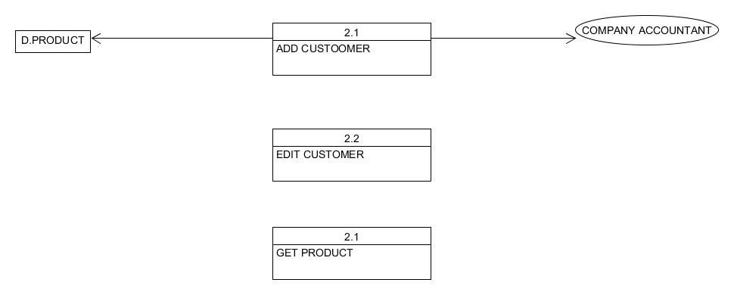

1. **Event response tables:**

|  |  |  |  |  |  |
| --- | --- | --- | --- | --- | --- |
| Event | Response | Trigger | Activity | Response | Destination |
| Login | user | user’sIdPassword | Store user’s record and password | Providing the actual Web page to user | user |
| Check | user | Transactioninformation | Check whether the transactions are available according to requirements | Showing Availability | user |
| Completing payment | user | Doing payment | Make transaction in whichever quota user want | Confirming transaction | user |
| Payment | user | Make Payment | Making payment of confirmed payment | Confirming payment | Administrator |
| Receivingpayment | Administrator | transaction Generation | Mailing or sending Hard copy of complete transaction | Sending detail of transaction to user | user |

**5.Questionarie (pyramid)**

1. **Have your system doing work for one company or more then one?(scalar)**
2. Do you want to provide different languages in which your system can be used? (Bipolar)
3. Budget for making system? (Scalar)
4. How many number of transaction can be booked at a time? (Scalar)
5. Working time? (Scalar)
6. Do you want to generate mail of confirming thetransaction? (Probe)
7. Who is going to use this system? (Close Ended)
8. Can rules and regulation be viewed by user on screen? (Open Ended)
9. What led you to make this system? (Open Ended)
10. Any additional facilities to be given to user? (Open Ended)
11. What kinds of information are required to log in or register in the system? (Open Ended)
12. Do you want to make feedback section in your status?(bipolar)
13. How many number of transaction can be done at a time?(scalar)
14. If any transaction can be done by user is it convey in history of admin?(close ended)
15. Which type of security you want?(open ended)

**6. Process specification forms:**

**:-Process specification for**

**7. Data Dictionary:**

user type=

            user type id+

            user type company master=

company id+

company name+

email+

password+

contact no+

user type id+

status+

bankaccoutno+

accont type

customer=

customerid+

customername+

email+

contactno+

productid+

employee=

employeeid+

employeename+

email+

salary+

contacno+

status+

address+

gender+

Product Category=

CategoryId+

CategoryName+

Product=

Productid+

Productname+

Productcategoryid+

price+

Description+

MfgDate+

Stock+

Sales=

Salesid+

        ProductId+

        SoldUnit+

        Amount+

        CustomerId+

        SalesDate+

        Status+

Account=

Accountid+

Accountname+

Accounttype+

Account type=

Accounttypeid+

Accounttype+

Balance Sheet=

JournalId+

ReferenceId+

EntryDate+

Notes+

Amount+

Status+

**8. output form:**

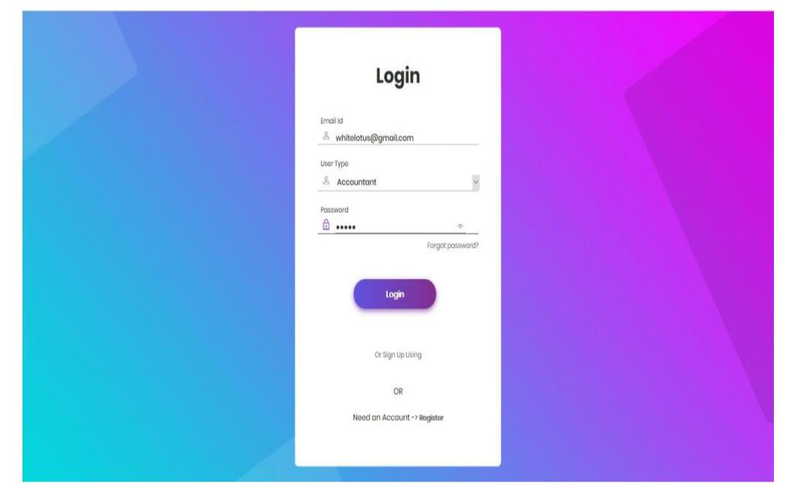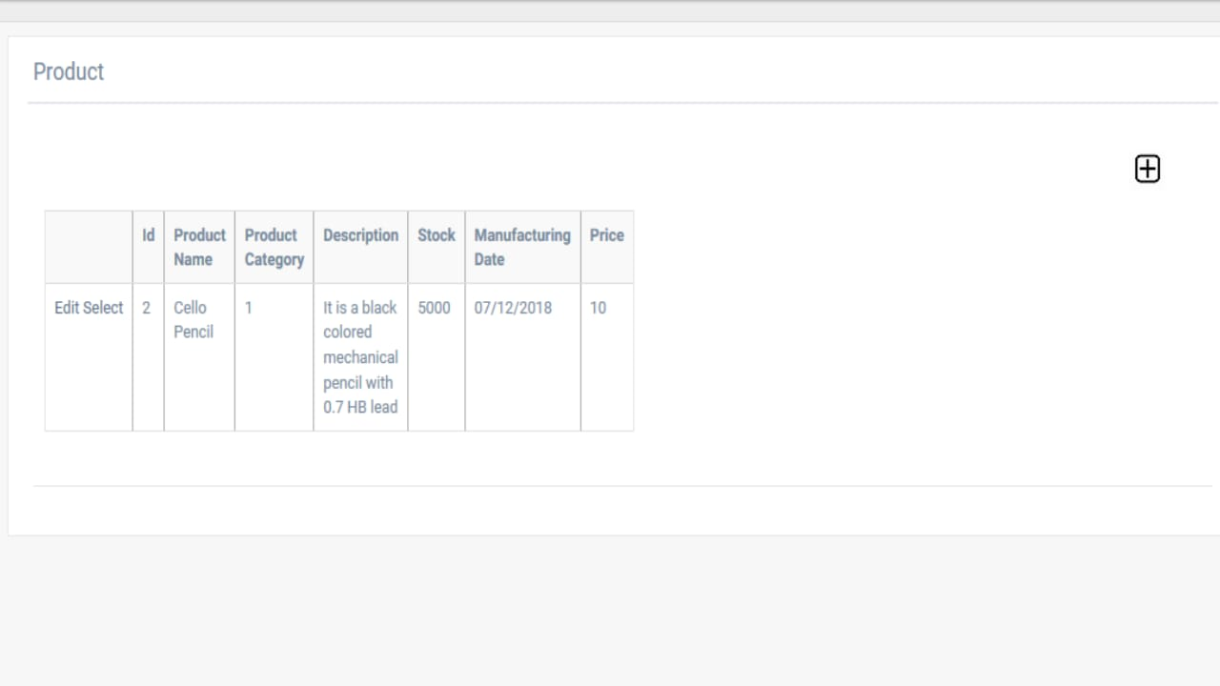

**9: input form:** 